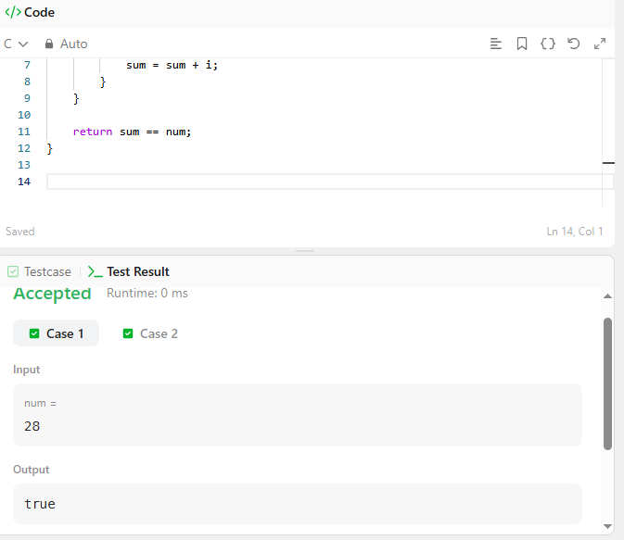
CODE –

bool checkPerfectNumber(int num) {
int sum = 0;

for (int i = 1; i < num; i++) {
if (num % i == 0) {
sum = sum + i;
}
}

return sum == num;
}

LINK –
https://leetcode.com/problems/perfect-number/

